PROJECT InTouch

Our project topic is InTouch which is basically a boon to the older ones of our community. This website will help them to move on with the present upgrading technology. The functionalities of our website include providing YouTube tutorials for their basic requirements like YouTube link for bill payments by connecting through API. The app also provides them remainders through connecting API on calendar. It also provides their location by the help of latitudes and longitudes and connecting API through Google maps.

We have used php,vsc,python,mysql,html as our back end and front end stacks.Inorder to access the above mentioned functionalities one has to visit our website InTouch.

We couldn’t hyperlink between our different pages.

LOGIN PAGE:

SIGNUP PAGE:

FEATURES:

Calendar:

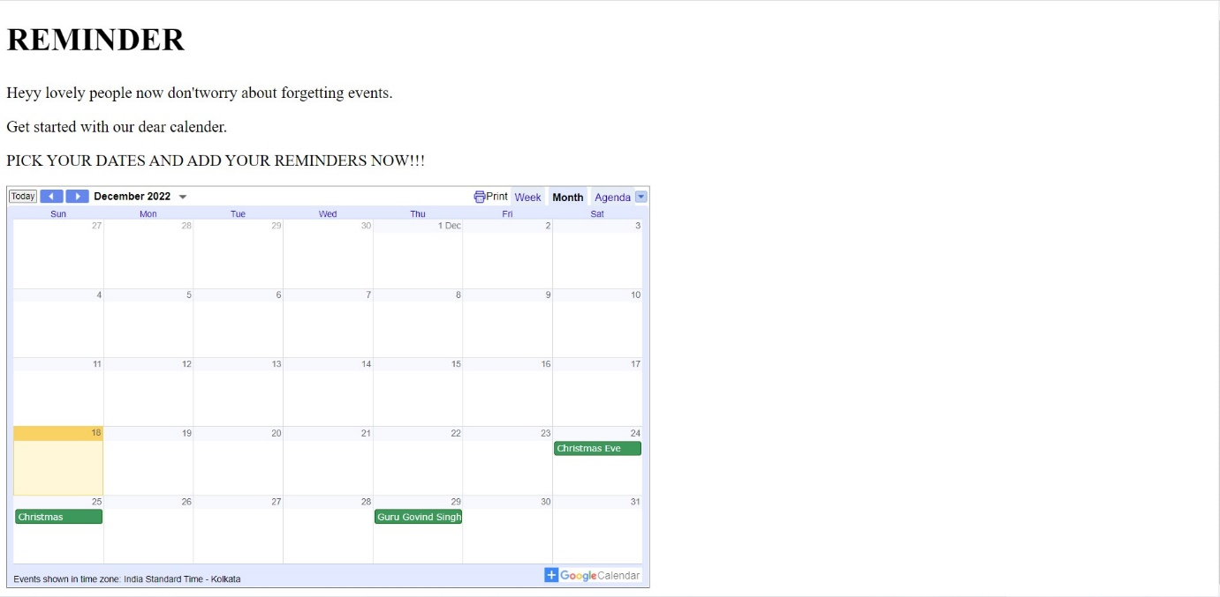

Tutorial

